**CSE 429 Course name: Compiler Design Quiz: 1**

**Marks: 20 Time: 20 minutes**

1. Draw parse tree and write down the three-address code for the following expression. [4]

x = a^2 + b * (c + d)

2. Consider the following FA over alphabet ∑= {0, 1, 2}. This FA also has an additional transition from state 0 to state 1 over alphabet **X**, where **X= Last two digits of your ID%3.** Now draw the transition table as well as the updated finite automata diagram. Also, with proper reasons please specify if the above stated automata is a DFA or NFA. [3+3+3]

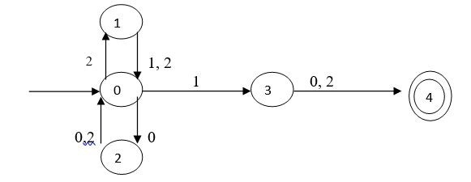

3. Write a regular expression for the following language:

1. The set of strings over alphabet ∑= {a, b} which starts with aba and ends with bab. [2]
2. The set of all strings of 0’s and 1’s containing 101 as a substring. [2]

4. Write the problem statement of the following RE: [3]

**(0|1)* 01 + (0|1)* 10**